**Profile Management**

A user profile is a visual display of personal data associated with a specific user, or a customized desktop environment. A profile refers therefore to the explicit digital representation of a person's identity. A user profile can also be considered as the computer representation of a user model.

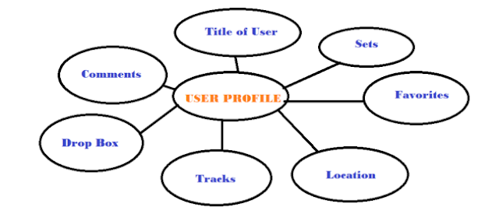

/etc/profile - it contains system void variables, if you do any modification in this file it will effect to the administrator and local user profiles.

~/.bash_profile - it contains user specific variables, if you do any modification in this file it will effect to that particular account only.

/etc/bashrc - it contains system void alias variables

~/.bashrc - it contains user specific alias variables

.bash_history - it contains all executed commands history

Commands:

# alias - it will show the aliases

|  |
| --- |
|  |
| ailas Command Output |

# unalias <alias name> - it will remove mentioned alias

Note: you can always define an alias using /etc/bashrc OR .bashrc files

File Permissions:

|  |  |  |
| --- | --- | --- |
| Permission | Value | Number |
| Read | r | 4 |
| Write | w | 2 |
| Execute | x | 1 |

Default permissions when you create a file or directory

|  |  |
| --- | --- |
| File Permissions | |
| File | 644 |
| Directory | 755 |

|  |
| --- |
|  |
| File and Directory Permissions |

In above image explained about file permissions

Commands to Change file/directory permissions

Symbolic permissions

u - user/owner

g - Group

o - Others

w - Write

x - Execute

+ - Allow

- - deny

# chmod [options] <mode/permissions> <file/directory> - to change permissions file/folder

Example: chmod 744 file1

# chmod u+rwx file or directory : in case of user only

# chmod ug+rwx file or directoty : in case of user and group

# chmod u+w,g+r,o+x directory/file

# chmod u+rw,g+rw directory/file

# chmod u-r, g-w,o-rw directory/file

# chmod ugo+rwx file/directory

# chmod ugo-rwx file/directory

# chown [options] <new owner> <file/directory> - to change ownership of file/folder

Example: chown user2 file1

chown user1:group1 file2

# chgrp [options] <new group> <file/directory> - to change group of file/folder

Example: chgrp gorup2 file2